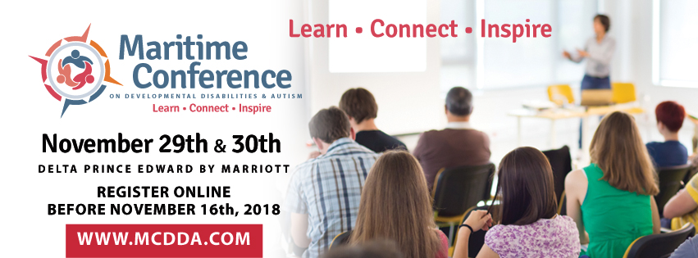
Nomination Form
Outstanding Achievement Award
The Maritime Conference on Developmental Disabilities and Autism is pleased to recognize individuals who identify as a person with a disability (developmental, dual and/or autism) with an Outstanding Achievement Award to be presented at the Award Luncheon being held on Friday, November 30, 2018
This award recognizes a person who has identified as a person with a developmental, dual disability and/or on the autism spectrum who provides an inspiration to those that know and/or a role model to others. This award may recognize achievements in culture, employment, community inclusion, and/or the overall capabilities of persons with a disability.
The following person is hereby nominated:
Name: _____________________________________________
Address: _____________________________________________
Phone: _____________________________________________

Along with this form, please attach a one page profile of the nominee that clearly states how the nominee meets one or more of the Award Criteria as described above.
Submitted by: _____________________________________________
Seconded by: _____________________________________________
Date: _____________________________________________

ALL NOMINATIONS MUST BE RECEIVED BY NOVEMBER 16, 2018.
Please return completed Nomination Forms to:
Attn: Nancy Anderson via email nancy@inclusionseast.com or by mail at PO Box 563, Montague PE C0A1R0 or in person to 364 Campbell Ave. Montague PE

